Supplementary Item –

Covid 19 Response

Quarter 1 2020-21

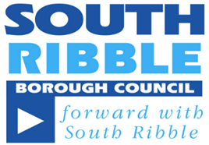

The Council faced the unprecedented challenge of Covid-19, but through a team effort was able to continue to key and additional services. Digital and technology acted as a major enabler to sustain existing services and implement additional service provision and new ways of working. Remote working solutions enabled officers to remain responsive to local need and was instrumental in establishing a Covid-19 specific contact centre, online self-serve and data management processes.

Digital also re-established critical council decision making functions including member committee meetings with the first virtual committee on 4th June. Following successful tests, a hybrid virtual and physical committee model was established enabling the meeting of Council to take place on 22nd July.
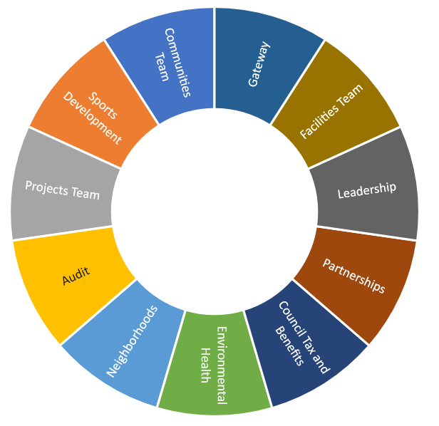

South Ribble Together: Community
The ‘Community’ support was established in just over a week, and between April – June at least 39 employees were redeployed from across the Council, to positions outside their substantive roles to. Total staffing levels fluctuated but employees who were willing, were redeployed from across different teams illustrated to the right.
- Total no. individuals we have sent postcards / letters to | 13,800
- Total no. individuals we have contacted via outbound calls | 6,083
- Total no. individuals who contacted us | 2,826
- Total no. individuals that have received support | 882
- Total no. food parcels requested and issued | 722
- Total no. individuals that have received support on multiple occasions | 376
- Total no. individual prescription collections | 296
- Total no. repeat prescription collections | 52

South Ribble Together: Business Support
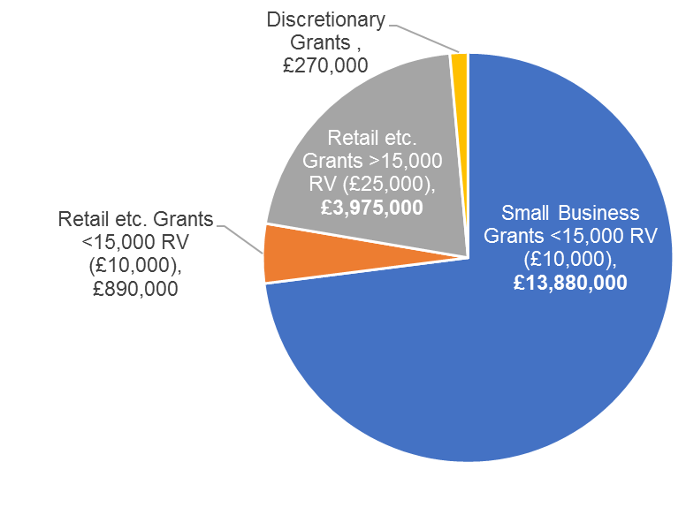
Investment and Skills and Revenues and Benefits focused on providing the range of business grants made available from the government. would receive grants from the government.
This included a proactive approach to driving businesses through the application process and to date over £19 million pounds has been distributed.

Council Tax and Rates
The gateway and, revenues and benefits teams also focused on responding to Covid-19. During the period the teams:
- Responded to over 8,000 calls to Council Tax;
- Completed over 5,200 Council Tax scripts, of which over 1,200 related to making/altering payment arrangements;
- Dealt with an increase in caseload of the number of working age claimants needing support from 3,273 to 3,771 (498 additional claims)
- Supported retail properties entitled to relief with an increase from 219 properties granted approx. £904,605 to 430 properties granted approx. £12,700,000 (211 additional reliefs).

